**What distinguishes our hospital:**

- The location of the hospital is very suitable, as it is a more social location in the middle of the city.

-We verify the accuracy of the data and the speed of access by the ambulance crew to the site of the patient or injured person.

-All patient data is examined by doctors and is often written by them.

-A hospital with a capacity of 600 to 1000 beds.

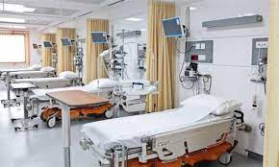

-A healthcare institution that provides treatment to patients by specialized medical and nursing staff and medical equipment.

-Intensive care unit for critical cases or cases that require special care. - The emergency unit that deals with emergency cases that do not need to wait and require rapid intervention from doctors.

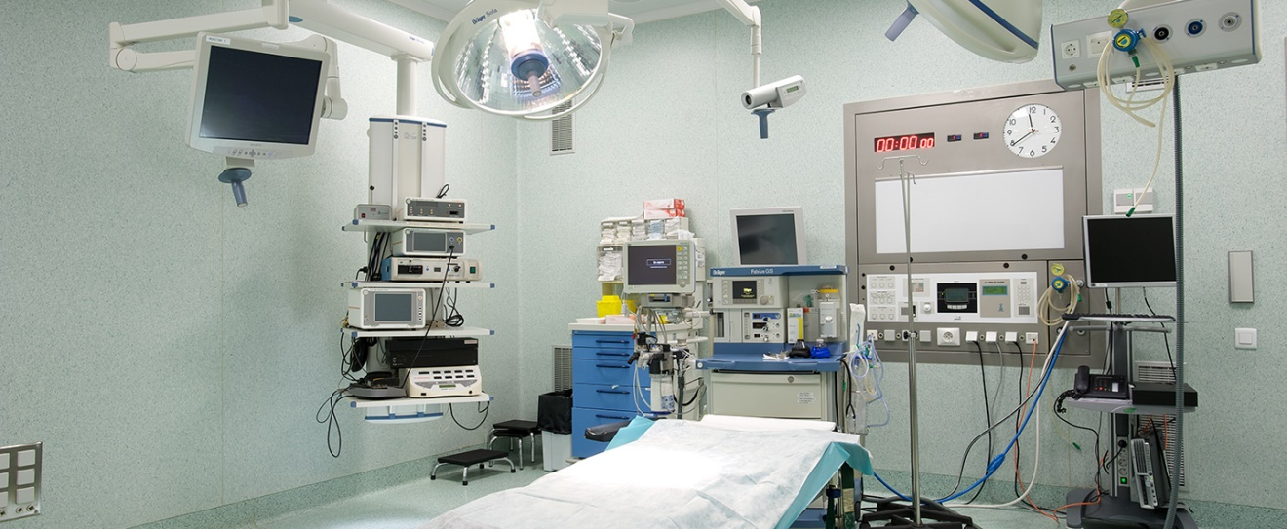

-sections:

We have many treatment departments inside the hospital, equipped with a staff of qualified doctors for each department.

- Examination devices:

The hospital has all the advanced devices that help in the careful examination of patients, and they are also available in the intensive care rooms.

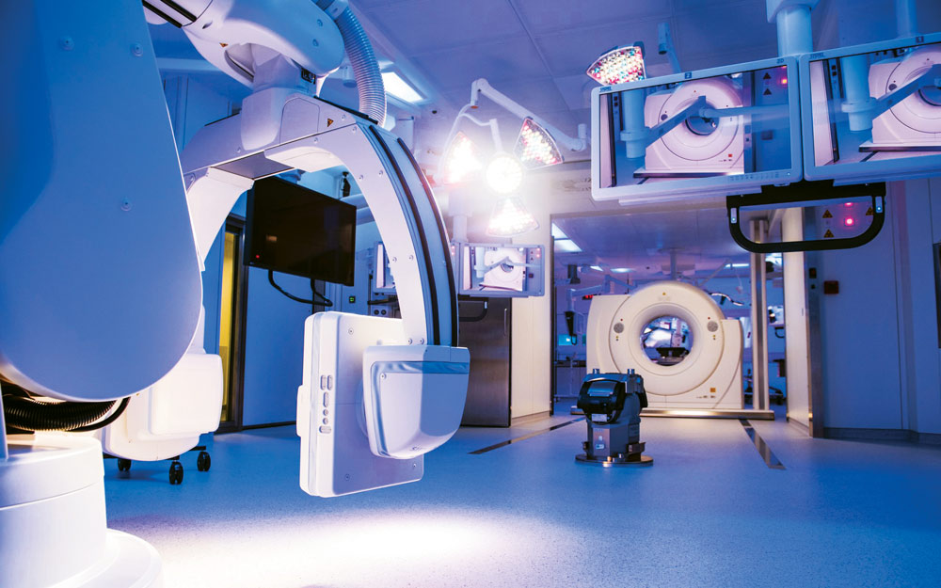

By:

فاطمة عبد الصمد عثمان

علياء امبارك قابيل

فاطمة محمد عبد الدايم